**Introduction to POE PART 1 – PROGRAMMING**

For this POE PART 1, the application report that will be made is based on my UML Class Diagram and Windows Presentation Form Application.   
  
I will be providing a detailed explanation of my design choices, also the structure of my SQL Database creation and layout of the GUI Windows WPS.   
  
Everything will be uploaded into GitHub and Sceen Shots will be shown in this report project.   
  
A Complete Project Plan will be outlined as mentioned in the Rubric, containing the Outline of Tasks, Who are the Dependencies, What Timeline is being used and a physical prototype will be presented.   
  
The GUI Design will be Front-End Prototype designed and will contain limited options regarding the UML Attributes and Characters.

Darshan’s POE PART 1 _ PROG

Contents

DOCUMANTATION 4

Windows Presentation Form (WPS) 4

SQL Server Database 4

GUI – Layout 4

UML CLASS DIAGRAM 5

UML Explaination 6

PROJECT MANAGEMENT – TASKS 7

Project Overview Below: 7

GUI – Design & Screenshots + Explainations 11

Main – Window 11

Lecturer – Window 12

Programme Co-Ordinator – Window 13

Academic Manager – Window 14

Create Account – Window 15

Claim – Window 16

Supporting Documents – Window 17

View Reports – Window 18

Version Control – GitHub 19

References 19

# DOCUMANTATION

## Windows Presentation Form (WPS)

For my Design choices, I have gone with Windows Presentation Form, which will be supper easy to navigate around, the design is simple and will be professional for all Lecturers to use to support their Contract Monthly Claims System. Furthermore, the System’s Integration will go beyond the basic works, providing a seamless platform for necessary documentation support and gives little to no room for errors.

## SQL Server Database

The structure of the Database will allow all Attributes to be accessed and modified if needed. Students, Lecturers, Program Co-ordinators and Academic Managers will be able to sort out the accuracy and accountability in the administration process.

## GUI – Layout

The Design will be like opening up a Windows Document. Everything will be joined by coding C# language; the implementation will provide access to documents and whomever shell make use of the GUI will be able to modify anything.

# UML CLASS DIAGRAM

## UML Explaination

**(1) – Lecturer Table**  
**Attributes** – LecturerID, LecturerFirstName, LecturerSurname, LecturerEmail, LecturerCourse.   
**Methods** – SubmitClaim() , ViewClaim()  
**Foreign Key** – ClaimID  
**Primary Key** - LecturerID

**(2) – Claim Table**  
**Attributes** – ClaimID, HoursWorked, HourlyRate, TotalAmount, Status, CalculateTotal,   
**Methods** – CalculateTotal(), AddSupportingDoc ()  
**Foreign Key** – DocID, LecturerID  
**Primary Key** - ClaimID

**(3) – Supporting Document Table**  
**Attributes** – DocID, FilePath, FileType.  
**Methods** – UploadDoc(), ViewDoc ()  
**Foreign Key** – ClaimID  
**Primary Key** - DocID

**(4) – Programme Co-ordinator Table**  
**Attributes** – ProCo-ordinatorID, ProFirstName, ProSurname, ProEmail, ProCourse.  
**Methods** – ReviewClaim(), RequestAddInfor ()  
**Foreign Key** – ClaimID, DocID  
**Primary Key** – ProCo-ordinatorID

**(5) – Academic Manager Table**  
**Attributes** – AcaManagerID, ManFirstName, ManSurname, ManEmail, ManCourse.  
**Methods** – ViewClaim(), RejectClaim(), ApproveClaim(), ViewReports().  
**Foreign Key** – ClaimID, DocID, ProCo-ordinatorID  
**Primary Key** – AcaManagerID

**Relationships (UML Table)   
  
A Lecturer** can submit many **Claims**.  
**A Claim** can have many **Supporting Documents**.  
**A programme Co-ordinator** can review many **Claims**.  
**An Academic Manager** approves or can reject many **Claims**.

# PROJECT MANAGEMENT – TASKS

## Project Overview Below:

Objective: To provide the Lecturers and Students with an understanding of the WPS Application for claims submission and approval by Lecturers and Academic Managers.

**Time Taken to Complete: 1 Week = (7 Days)  
Number of Hours Taken: 40 Hours  
Team: Just one person (Darshan Pyda, myself)**.

Below is the Phases and Table:

|  |  |  |  |  |
| --- | --- | --- | --- | --- |
| **PHASES:** | **Tasks** | **Descriptions** | **Time Taken** | **Dependencies** |
| **PHASE 1** | **Basic Starting WORD DOC Requirements.** |  |  |  |
|  | (1.1)  Receiving the PROG - POE Assignment. | Looking through POE PROG - Part 1. | 4 Hours | Nothing |
|  | (1.2) Understanding the POE step by step. | First what is being asked of me in the POE Question 1 : DOCUMENTATIONS | 4 Hours | Task 1.1 |
| **PHASE 2** | **Document Designing Page Introduction** |  |  |  |
|  | (2.1) Creating the Required UML Class Diagram in CANVA APP. | Creating and Screenshotting the Image into WORD DOC. Then providing the Link. | 4 Hours | Task 1.1 |
|  | (2.2)  Providing an explanation as to what are the attributes in each table and, what methods + primary & foreign keys. | Typing all the required information and making sure its correct and completes Question 2; UML Explanation & Business Reasons | 2 Hours | Tasks 1.1 & 2.1 |

|  |  |  |  |  |
| --- | --- | --- | --- | --- |
|  | (2.3)  Set up Visual Studio 2022 and create GUI Names WPS Pages based on UML CLASS. | Creating POE PROG – PART 1 Project, GUI WPF Windows pages and settings. | 3 Hours | Task 2.1 & 2.2 |
| **PHASE 3** | **Question 4; GUI & Visual Studio 2022** |  |  |  |
|  | (3.1)  Start to design the 1st Window page | Designing the Main Starting Window of the Application and providing an explanation in the WORD DOC. | 2 Hours | Task 2.2 |
|  | (3.2)  Starting to design the 2nd Window page | Designing the Lecturers Window and providing an explanation in the WORD DOC. | 2 Hours | Task 3.1 |
|  | (3.3) Starting to design the 3rd Window page | Designing the Claim Window and providing an explanation in the WORD DOC. | 2 Hours | Task 3.2 |
|  | (3.4) Starting to design the 4th Windows page | Designing the Program Co-ordinator Window and providing an explanation in the WORD DOC. | 2 Hours | Task 3.3 |
|  | (3.5) Starting to design the 5th Windows page | Designing the Academic Manager Window and providing an explanation in the WORD DOC. | 2 Hours | Task 3.4 |

|  |  |  |  |  |
| --- | --- | --- | --- | --- |
|  | (3.6) Starting to design the 6th Windows Page | Designing the Create Account Windows page for any Lecturer, Academic Manager or Programmer Co-ordinator & WORD DOC explanation as well. | 2 hours | Task 3.5 |
|  | (3.7) Starting to design the 7th Windows Page | Designing the Supporting Documents Window page and providing an explanation in the WORD DOC. | 2 Hours | Task 3.6 |
|  | (3.8)  Starting to design the 8th Window Page | Designing the ViewReports Windows page and providing an explanation in the WORD DOC. | 2 Hours | Task 3.7 |
| **PHASE 4** | **Question 5:  GIT HUB Work** |  |  |  |
|  | (4.1)  After all the WORD DOC, then create a Git Hub Project with a Tag. | Create a Git Hub Project, place everything into the project, screenshots, report and tag creation + make the link simple | 2 Hours | Task 3.8 |
|  | (4.2)  References all Links | Get the Git Hub link into the WORD DOC, and all other links to complete the project. | 2 Hours | All Tasks |
| **PHASE 5** | **Project Management** |  |  |  |
|  | (4.3)  Once all this has been completed and timed correctly then all times and records are placed in the Project Management Plan | Insert information to Project Planner for WORD DOC POE. | 3 Hours | All Tasks have to be completed for this to work as per rubric. |

# GUI – Design & Screenshots + Explainations

## Main – Window

**Main Window** – This has a Welcome Message to all staff of the Rosebank College, Cape Town Campus Educational Institution.   
**Users** – Lecturer, Programmer Co-Ordinator or Academic Manager; They can either sign in to continue they respective duties and responsibilities or if its someone new, he/she can Create an Account, since the option is available to them.   
**Design** – This consists of four different Buttons and one large Text, as seen in the Screenshot above.

## Lecturer – Window

**Lecturer Window** – This has a Welcome Message to all staff of the Rosebank College, Cape Town Campus Educational Institution.   
**Users** – Lecturer, or new Account Creator.   
**Design** – This Window has two Buttons, three Texts and two Lines for filling in Details.

## Programme Co-Ordinator – Window

**Programme Co-Ordinator Window** – This has a Welcome Message to all staff of the Rosebank College, Cape Town Campus Educational Institution.   
**Users** – Programme Co-Ordinator, or new Account Creator.   
**Design** – This Window has two Buttons, three Texts and two Lines for filling in Details.

## Academic Manager – Window

**Academic Manager Window** – This has a Welcome Message to all staff of the Rosebank College, Cape Town Campus Educational Institution.   
**Users** – Academic Manager, or new Account Creator.   
**Design** – This Window has two Buttons, three Texts and two Lines for filling in Details.

## Create Account – Window

**Create Account Window** – This has a Welcome Message to all staff of the Rosebank College, Cape Town Campus Educational Institution.   
**Users** –All Staff, or new Account Creator.   
**Design** – This Window has five Buttons, One Main Texts and eight other Texts for filling in Details.

## Claim – Window

**Claim Window** – This has a Welcome Message, It’s for All the Lecturers who wish to submit Claims to the Programmer Co-Ordinators.   
**Users** –All Lecturers Only.   
**Design** – This Window has seven Buttons, One Main Text and two other Texts for checking Status Details for the Lecturer.

## Supporting Documents – Window

**Supporting Documents Window** – This has a Welcome Message, It’s for All the Programmer Co-Ordinators who wish to Approve/Dis-Approve Claims to the Academic Manager.   
**Users** – Programmer Co-Ordinators Only.   
**Design** – This Window has five Buttons, One Main Text and two other Texts for Status Details for the Programmer Co-Ordinators.

## View Reports – Window

**View Reports Window** – This has a Welcome Message, It’s for All the Academic Managers who wish to View Claims from the Programmer Co-Ordinators & Lecturers.   
**Users** – Academic Managers Only.   
**Design** – This Window has four Buttons, and one Main Text.

# Version Control – GitHub

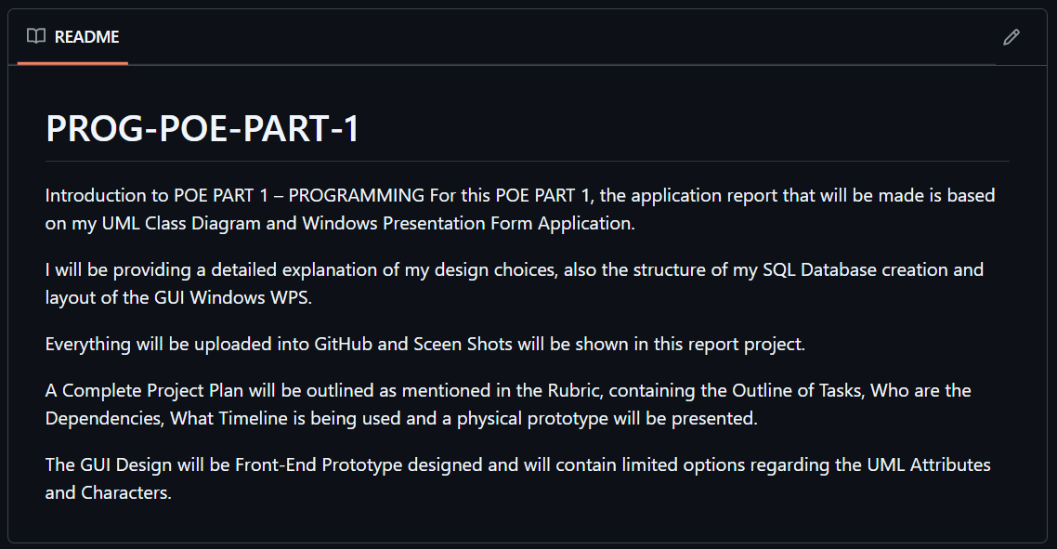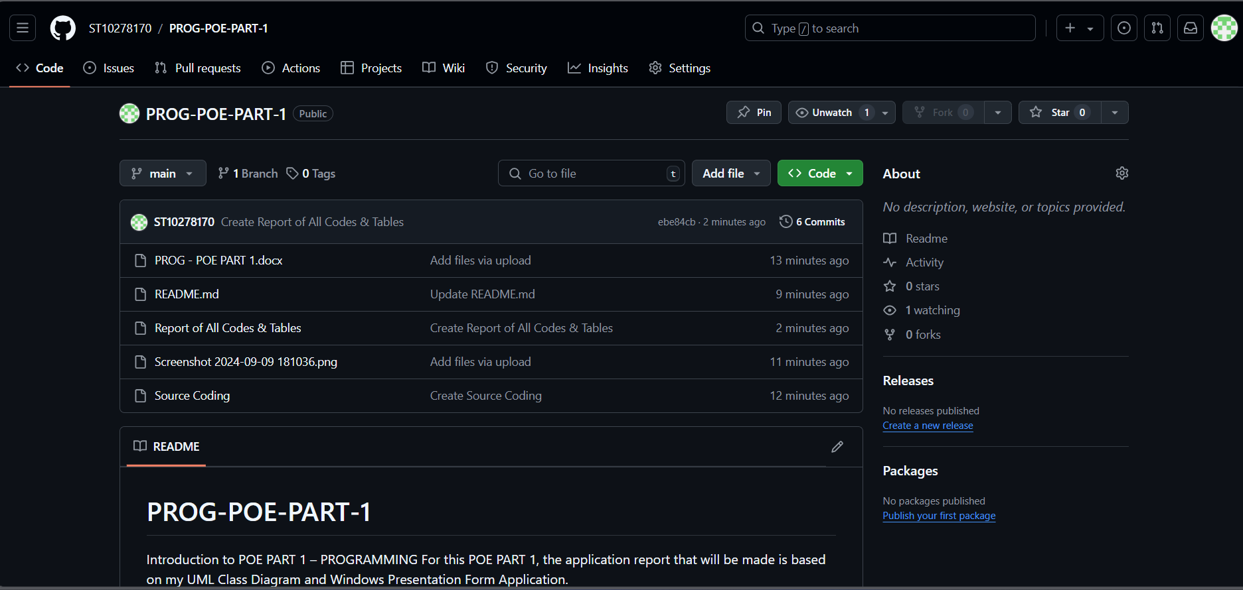[ST10278170/PROG-POE-PART-1 (github.com)](https://github.com/ST10278170/PROG-POE-PART-1/tree/main)

# References

<https://www.canva.com/design/DAGP-2gdEkk/iXkMw84NZ5sZRczaksBdjA/edit?utm_content=DAGP-2gdEkk&utm_campaign=designshare&utm_medium=link2&utm_source=sharebutton>

[] Carlos Coronel, Steven Morris, Keeley Crockett - Database Principles_ Fundamentals of Design, Implementation, and Management (2020, Cengage)(Z-Lib.io).pdf

[ST10278170/PROG-POE-PART-1 (github.com)](https://github.com/ST10278170/PROG-POE-PART-1/tree/main)